

FACULTY OF SCIENCE AND ENGINEERING

DEPARTMENT OF MATHEMATICS & STATISTICS

END OF SEMESTER ASSESSMENT PAPER

MODULE CODE: MA4605 | SEMESTER: Autumn 2010

MODULE TITLE: Chemometrics | DURATION OF EXAM: 2 ½ hours

LECTURER: Ana-Maria Magdalina | GRADING SCHEME:  Examination 50%

EXTERNAL EXAMINER:

INSTRUCTIONS TO CANDIDATES
_____________________________________________________________________
- Answer all five questions.
- Mark clearly on the answer sheet the question number that you are answering.
- All questions carry equal marks.
- UL approved calculators may be used.
_____________________________________________________________________
Q1. An analyst is investigating a sample of 10 sediment probes from a potentially contaminated area. The nickel concentrations are given below in parts per million (ppm).
Sample | 1 | 2 | 3 | 4 | 5 | 6 | 7 | 8 | 9 | 10
Nickel concentration (x) | 72.5 | 62.0 | 63.7 | 47.4 | 54.8 | 55.0 | 51.9 | 52.8 | 66.0 | 49.5
The sediment quality guideline for nickel is a maximum value of 52 ppm.
Two t-tests have been performed to check if the area is significantly contaminated or the difference between the sample mean of 57.56 ppm nickel and the maximum level occurs due to random error. The sample standard deviation of nickel is 19.45 ppm.

Test 1  t.test(x,mu=52) | One Sample t-test  data: x  t = 2.1736, df = 9, p-value = 0.05778  alternative hypothesis: true mean is not equal to 52  95 percent confidence interval:  51.7734 63.3466  sample estimates:  mean of x  57.56
Test 2  t.test(x,mu=52,alternative="g") | One Sample t-test  data: x  t = 2.1736, df = 9, p-value = 0.02889  alternative hypothesis: true mean is greater than 52  95 percent confidence interval:  52.87089 Inf  sample estimates:  mean of x  57.56

- Extract and interpret the 95% confidence interval for the nickel concentration. Knowing that the quantile qt(0.975,df=9)=2.26, explain how this interval is calculated. (4 marks)

- Select the appropriate t-test that will indicate if the sediment is contaminated above the safety level.
(4 marks)
- Clearly state the null and the alternative hypothesis of the test you chose at point (b) and interpret its output.
(6 marks)

- What is the assumption required for this test? Check if the assumption holds by analyzing the output from the Anderson-Darling test.
Clearly indicate the null and the alternative hypothesis.

Anderson-Darling normality test
data: x
A = 0.3228, p-value = 0.4624
(6 marks)
Q2. Assume that two samples were obtained for the nitrate concentrations (mg l⁻¹) from two lakes. The size of both samples is 20.

- Are these data suitable for a paired t-test? Justify your answer.
(2 marks)
- The normality of the two samples is checked below. Interpret the R output.
Clearly indicate the null and alternative hypothesis.

Anderson-Darling normality test
data: sample1
A = 0.4113, p-value = 0.3098

Anderson-Darling normality test
data: sample2
A = 0.3819, p-value = 0.3658
(4 marks)

- Test the assumption that the two samples are extracted from populations with equal variances. Clearly indicate the null and alternative hypothesis.
Interpret the 95% confidence interval for the ratio of variances.

F test to compare two variances
data: sample1 and sample2
F = 0.4365, num df = 19, denom df = 19, p-value = 0.07864
alternative hypothesis: true ratio of variances is not equal to 1
95 percent confidence interval:
0.1727879 1.1028970
sample estimates:
ratio of variances
0.4365401
(6 marks)
- Test the claim that nitrate concentrations are equal in the two samples.
The results of two t-tests for equality of means are presented below.
Which one is appropriate for our data? Why?
(8 marks)
Test 1  t.test(sample1,sample2) | Two Sample t-test  data: sample1 and sample2  t = -4.3116, df = 32.933, p-value = 0.0001383  alternative hypothesis: true difference in means is not equal to 0  95 percent confidence interval:  -0.18914 -0.06786  sample estimates:  mean of x mean of y  0.3991 0.5276
Test 2  t.test(sample1,sample2,var.equal=T) | Two Sample t-test  data: sample1 and sample2  t = -4.3116, df = 38, p-value = 0.0001109  alternative hypothesis: true difference in means is not equal to 0  95 percent confidence interval:  -0.18883369 -0.06816631  sample estimates:  mean of x mean of y  0.3991 0.5276

Q3. The mercury level of several tests of sea-water from costal areas was determined by atomic-absorption spectrometry. The results obtained are as follows

Concentration  in µg l^{–1} | 0 | 10 | 20 | 30 | 40 | 50 | 60 | 70 | 80 | 90 | 100
Absorbance | 0.321 | 0.834 | 1.254 | 1.773 | 2.237 | 2.741 | 3.196 | 3.678 | 4.217 | 4.774 | 5.261

The analysis of the relationship between concentration and absorbance is obtained in R and presented below.

x<-seq(0,100,by=10)
y<- c(0.321, 0.834, 1.254, 1.773, 2.237, 2.741, 3.196, 3.678, 4.217, 4.774, 5.261)
model<- lm(y~x)
summary(model)

Call:
lm(formula = y ~ x)

Coefficients:
Estimate Std. Error t value Pr(>|t|)
(Intercept) 0.2933636 0.0234754 12.50 5.45e-07
x 0.0491982 0.0003968 123.98 7.34e-16
---

Residual standard error: 0.04162 on 9 degrees of freedom
Multiple R-squared: 0.9994, Adjusted R-squared: 0.9993
F-statistic: 1.537e+04 on 1 and 9 DF, p-value: 7.337e-16

(a) Sketch the data and describe the relationship between the two variables.
(2 marks)

(b) Determine and interpret the slope and the intercept of the calibration plot.
(2 marks)

(c) Knowing that qt(0.975,df=9) is 2.26, calculate the 95% confidence interval for the slope and the intercept parameters.
(2 marks)

(d) Explain in which way is the prediction in calibration different from the prediction in the usual linear regression?
(2 marks)

(e) Using the fitted line calculate the predicted value of the Hg concentration
when the Absorbance is 3. Estimate the 95% confidence interval for this
concentration. The following results obtained in R are necessary for
calculating the standard error of the concentration.

mean(y)
[1] 2.753273
mean(x)
[1] 50
sum((x-mean(x))^2)
[1] 11000

The formula for the standard error of the concentration is:
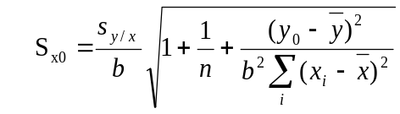, where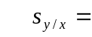0.04162.

(4 marks)

(f) Estimate the limit of detection of the mercury analysis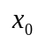, knowing that the corresponding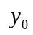 value is obtained with the formula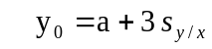.

(2 marks)

The following ANOVA table was extracted from the lm object.

Analysis of Variance Table

Response: y
Df Sum Sq Mean Sq F value Pr(>F)
x 1 26.6251 26.6251 15372 7.337e-16
Residuals 9 0.0156 0.0017
---

(g) Explain the ANOVA table. What does it test? Does it agree with the least
square method? Justify your answer.
(6 marks)

Q4.

Three investigators performed six determination of nitrate in water using the same procedure. The results in µM were:

Investigator 1 | Investigator 2 | Investigator 3
6.7 | 6.3 | 6.8
6.9 | 6.2 | 6.9
6.6 | 6.1 | 7.1
6.7 | 6.5 | 7.0
7.0 | 6.6 | 7.2
7.1 | 6.4 | 7.1

The analysis of variance is used to determine if there is a significant difference between the mean of the determinations made by the three investigators.

The following output is obtained in R and presented below.

investigator <- c(6.7,6.9,6.6,6.7,7,7.1, 6.3,6.2,6.1,6.5,6.6,6.4,6.8,6.9,7.1,7,7.2,7.1)

group <- factor(rep(1:3,each=6))

anova(lm(investigator~group))

Analysis of Variance Table
Response: investigator
Df SumSq MeanSq Fvalue Pr(>F)
group ? 1.42333 ? ? 3.133e-05
Residuals 15 ? ?
Total ? 1.9
---

- Fill in the missing values in the ANOVA table and explain how these statistics can be used to assess if there is any difference between the mean determinations made by the three investigators. Clearly state the null and alternative hypothesis.
(10 marks)

- What are the assumptions underlying ANOVA? Assess the validity of these assumptions interpreting the qqplot, the plot of the residuals and the Shapiro-Wilk and the Bartlett tests below. Clearly state the null and alternative hypothesis for the two tests.
(10 marks)

Shapiro-Wilk normality test

data: residuals
W = 0.9431, p-value = 0.3271

Bartlett test of homogeneity of variances

data: investigator by group
Bartlett's K-squared = 0.4142, df = 2, p-value = 0.813

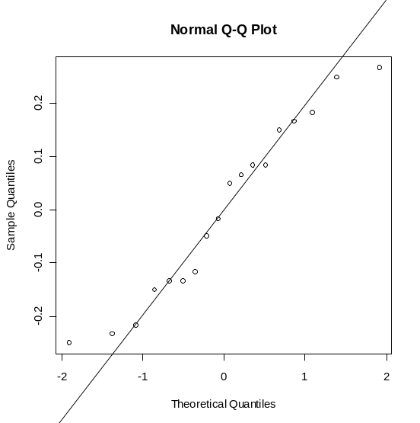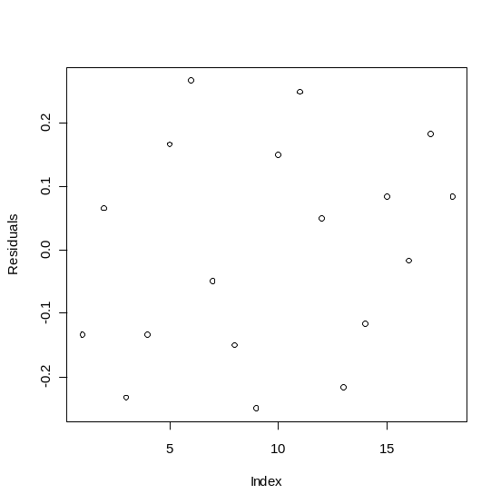

Q5.

Problem 1

Four standard solutions of chloride were prepared. Three titration methods, each with a different technique of end-point determination, were used to analyze each standard solution. The order of the experiments was randomized. The results of chloride found are shown below.

Solution | Method A | Method B | Method C
1  2  3  4 | 10.03  10.13  10.09  10.05 | 10.13  10.15  10.02  9.94 | 10.12  10.12  9.97  10.10

The following output table is the result of performing a two-way ANOVA without
interactions in R.

Analysis of Variance Table

Response: chloride
Df Sum Sq MeanSq F value Pr(>F)
A ? 0.012017 ? 1.2791 0.3446
B ? 0.011092 ? 0.7871 0.5435
Residuals 6 0.028183 ?

- Identify the two factors A and B, and their corresponding levels. Are they controllable or random? Construct the hypothesis statements.
(2 marks)
- Fill in the missing values for the mean sum of squares.
(2 marks)
- Test whether there are significant differences between the concentration of chloride in the different solutions, and whether there are significant differences between the results obtained by the different methods.
(2 marks)
- Interpret the following interactions plot.
(2 marks)
- Is it possible to include the interaction term in the model, given the data we have? Why? How can this be changed?
(2 marks)

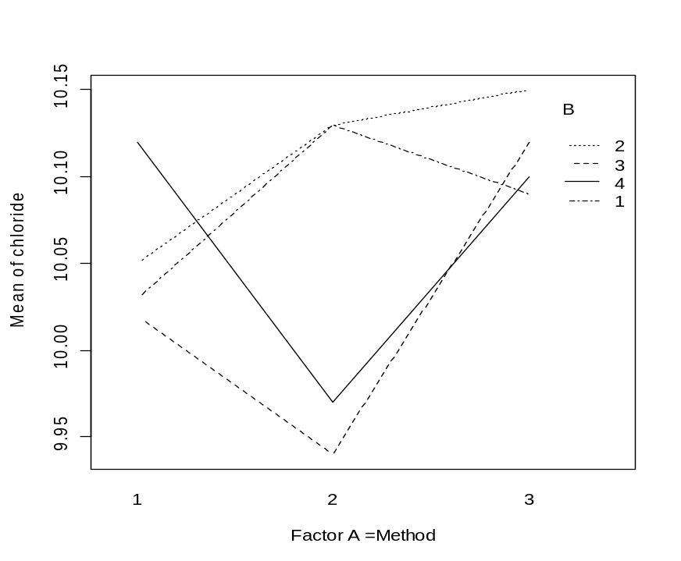

Problem 2

Three different chemical compounds A, B and C are measured in three separate laboratories. Each laboratory performed a duplicate analysis on each compound and the results are presented below.

 | Compound
Laboratory | A | B | C
1 | 5.1 , 5.1 | 5.3 , 5.4 | 5.3, 5.1
2 | 5.8, 5.4 | 5.4, 5.9 | 5.2, 5.5
3 | 6.5, 6.1 | 6.6, 6.7 | 6.5, 6.4

The following analysis was obtained in R by coding the compound as factor A and the different laboratories as factor B.

model <- lm(y~A+B+A:B)
anova(model)
Analysis of Variance Table
Response: y
Df Sum Sq Mean Sq F value Pr(>F)
A 2 0.1878 0.09389 2.3151 0.1545
B 2 5.0678 2.53389 62.4795 5.281e-06
A:B 4 0.1022 0.02556 0.6301 0.6533
Residuals 9 0.3650 0.04056

(a) Explain what is the design used.
(2 marks)
(b) Write conclusions to the present analysis.
(8 marks)

